The importance of knowing your patients' real hydration status
Classifying patients' nutritional status Diagnostic flexibility and speed

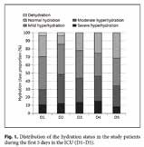
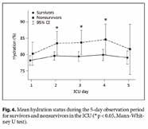
«Hydration status evaluation is a critical need for our patients, but we lack a "gold-standard" technique. Fluid retention of less than 3-4 litres without apparent oedema, or a moderate level of dehydration can be hard to identify clinically without the aid of a dedicated and sufficiently sensitive technique.» [1]

“70% of our inpatients were suffering from excess fluid retention, with the condition persisting for the entire period of hospitalisation” [2]

Hydration in a number: Hydragram®
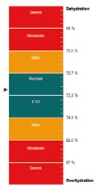
The Hydragram® system is the evolved application of bioimpedance vector analysis (BIVA) in clinical practice. With a simple graphic representation of hydration information that is comprehensible at a glance, the algorithm identifies the fluid percentage of Fat-Free Mass (tissue hydration) with a numbered and coloured scale whose predictive ability is unaffected by patient weight, age and body composition models.
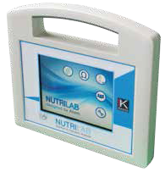
Values shown in percentage form mean normal physiological states (from 72.7 to 74.3%) can be identified instantly; any deviation towards congestion is shown with values between 74.4% and 81%, while deviations towards dehydration produce values of between 72.6% and 70%, according to curves plotted using Moore's equation (et al) [3]

NUTRILAB is a vector impedance technology device that can track fluid variations of less than 500cc.
Thanks to 20 years of clinical research into vector analysis, NUTRILAB stands at the pinnacle of the art of BIVA technology, combined with an innovative algorithm removes the interpretative difficulties of the classic RXc graph.

This type of evaluation is increasingly used with acute patients to support specific biomarkers such as BNP, Pro BNP or GAL3, and enjoys the support of European medical associations in emergency rooms, cardiology, nephrology, sports medicine and nutrition. [4, 5, 6, 7.]

“More than 40% of hospitalised patients suffer from either undernutrition or overnutrition.
The nutritional status of 67% of inpatients worsens during their stay in hospital" [8]

Many acute and chronic illnesses are accompanied by some form of related calorie or protein malnutrition or a combination of both, leading to complication of the clinical picture and related prognosis. It follows that precise and reliable evaluation of the patient's nutritional status is essential to assess the need for nutritional therapy and to measure the efficacy of any existing nutritional support.
Nutritional status can be evaluated by means of functional, metabolic, analytical and body composition parameters, although none of these can provide a comprehensive clinical picture when used alone.

Also the ability to define nutritional difficulties in addition to evaluating the exact level of malnutrition is invaluable from a therapeutic standpoint. Nutritional status can be evaluated by a physician or dietician, either directly or with the assistance of nursing staff.

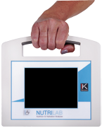
Nutrigram: the protein/energy malnutrition evaluation scale

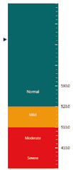
Nutritional status can now be evaluated using an index that is independent from body weight and body composition models. Creatinine excretion estimation (Ucr/24h) is performed by analysing the body cell mass quantity measured by the device. [9]
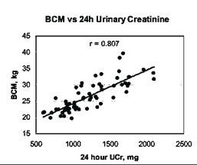
The result is standardised in relation to the patient's height and classified using the vector impedance technique in four intervals. Colour graphics allow simple and immediate identification of altered states of energy and/or protein malnutrition.

A specific and immediate creatinine height index based on body cell mass.
Creatinine is an indirect product of muscle cells, the main constituent of body cell mass.
The quantity of creatinine expelled is virtually constant over a 24 hour period and is relatively unaffected by other factors. The amount produced is therefore strictly correlated to the quantity of body cell
mass in the patient. [10]

«Nutrilab is a valuable aid for the evaluation of the hydro-electrolytic and protein metabolism of patients on artificial feeding regimes, both in hospital and at home.
The ability to perform the most widely used nutritional screening techniques in conjunction with BIA analysis allows me to work more efficiently and save time»
*MNA – Mini Nutritional Assessment
*MUST – Malnutrition Universal Screening Tool
*NRS 2002 - Nutritional Risk Screening
(ESPEN guidelines for nutrition evaluation)

“The evaluation of appendicular muscle in elderly patients is important to exclude the onset of sarcopenia. Finally I've got a transportable non-invasive solution with a standard estimation error of just 1 kg vs DEXA.”

Portable multifunction touch-screen system capable of performing nutritional analysis (diagnostic techniques specifically validated for sarcopenia, nutritional indices vs height) and hydration status (tissue hydration percentage) in the clinic or at the bedside: with an internal memory, lithium cell battery, touch-screen display; including the new PC management software (NUTRILAB Bodygram PLUS).
Complete with interactive nutritional screening questionnaires (MNA®, NRS 2002, MUST), total energy expenditure estimate with PAL, Ucr estimate vs height for nutritional evaluation, and standardised phase angle (SPA).
The new formulas for estimation of Appendicular Skeletal Muscle Mass (ASMM) in the elderly are highly correlated with Dexa (R² = 0.92). [11]
NUTRILAB combines precision with portability in a non-invasive, independent operator and extremely economical method.

New Bodygram PLUS interface for NUTRILAB
- Use of dynamic tissue hydration models: new FFM and FM estimation algorithms compensate for tissue hydration changes in the patient thus greatly increasing the accuracy of compartments prediction
- Guided interpretation: Akern recently developed and implemented specific semi-interpretive algorithms based on multivariate analysis, capable of assisting and guiding users in evaluating body composition of the tested subject
- Sarcopenia survey form
- Fast transfer of NUTRILAB databases to PC via USB
- Clear reporting

NUTRILAB - nutritional status on epidemiological basis
NUTRILAB - the nutritional and hydration monitor

Ω ?

NUT R ILAB
des igned by Akern
The use of percentile curves for fat free mass index (FFMI), fat mass index (FMI) and body cell mass index (BCMI) assists the clinician in longitudinal evaluation of nutritional status; the parameters are used for assessment of fat-free mass deficit, with or without excess fat mass (sarcopenic obesity). While BMI is linked to body mass 'quantity', FFMI, FMI and BCMI
describe body composition 'quality'. In adults, the body height indices can highlight even small minor quantity changes that percentage values tend to conceal in the presence of continual changes in body weight. [12]

“All healthcare intervention strategies are primarily aimed at early identification of clinical prognostic indicators and instrument readings that can be used to diversify the intensity of follow-up protocols after discharge and optimise treatment of patients at high risk of events in the short and medium term.” [6]

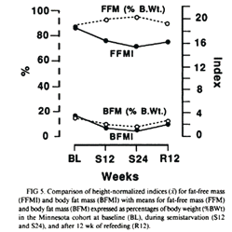
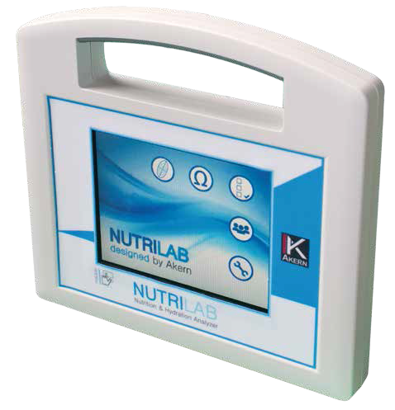
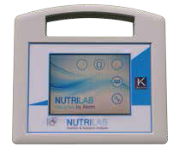

NUTRILAB developed by the body composition experts
NUTRILAB working with users for instant bedside evaluation

